Present this voucher at the next cake sale and get any 2 cakes of your choice for just 10p.

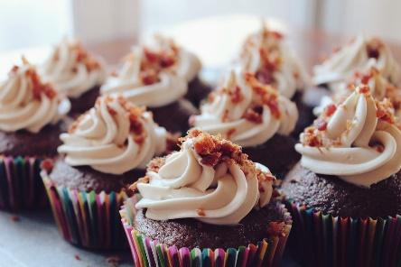
E-Voucher

www.bbc.co.uk/food/fairy_cakes

